Trigger Trap

Overview
The game is about two players trying to tactically outsmart one another. The goal is to kill an enemy player or to gather all 2 gems (they lower the enemy health by half so when all gems are collected the enemy dies). In order to damage the player he must get hit by either by a player or his trap but there are some non lethal traps already on the map (like a trap that marks your location on your enemy’s map). The map is middle size but the catch is that the players see only a small part of the map they are located in so information gathering is necessary to win over the opponent. Also the game has no story because it’s literally two rectangles killing each other.

Gameplay
players


The player can move in all 4 directions on a pseudo 3d like environment using arrow keys and picking or placing traps using mouse. When the trap is placed it may be already active or in some cases it may need to be activated using a different trigger. When player gets a trap he may place only a certain number of them on the map.
Player Placement
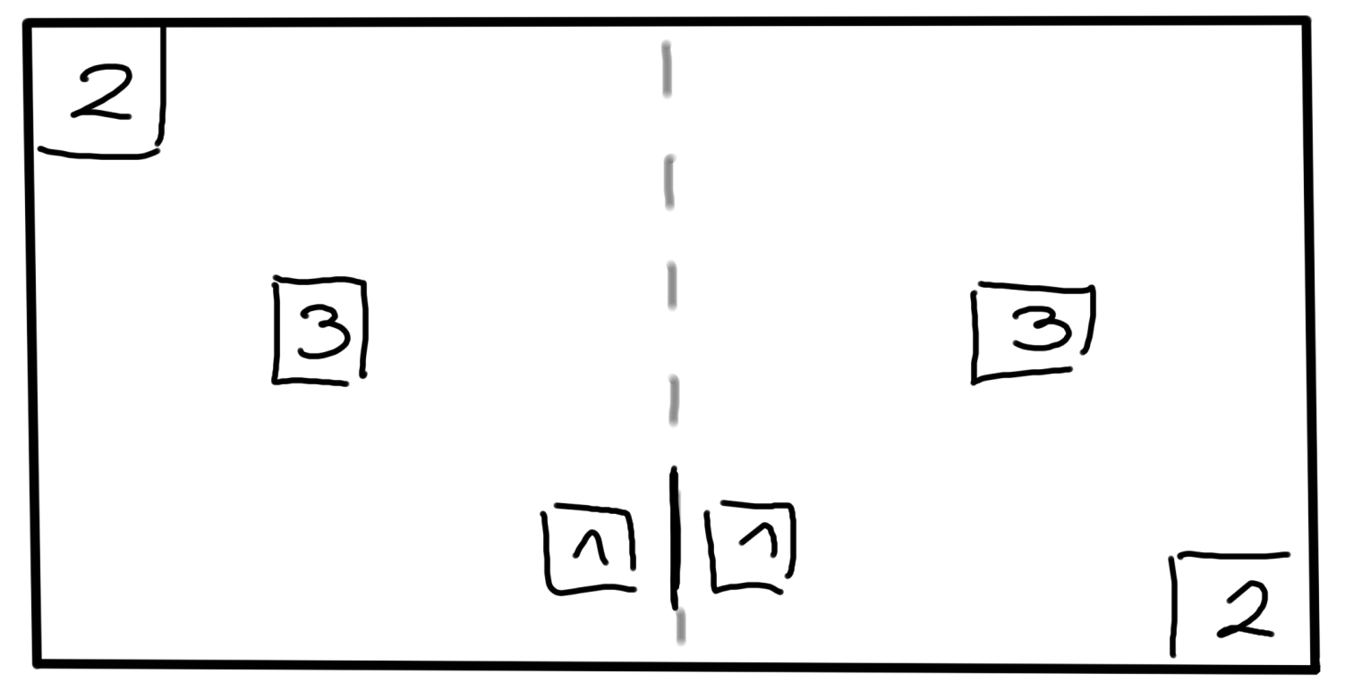
The game starts with players getting placed on random predefined location on map. For example the randomizer could return 1 which would place players in location number 1 etc.
Every player has 2 gems (every on an enemy’s side and maybe? A additional one in he middle for both players) which he might want to collect. When one of the player collects a gem it lowers his enemy’s health by half which means collecting 2 gems is equal to winning the game. Also all players know the locations of all gems on the map (so they can set traps or ambush the player trying to get them) and the gems spawns randomly on the map.
The supply drop is an event that sometimes occurs for firstly one player and then the other player after the first one has finished collecting it. It is something of a lootbox with random trap inside. The thing with it is that when it appears on your map you never know if you are the first player (the one who loot) or the second (the one who gets killed by traps set by the first player).
Players may sometimes find useful items hidden on the map. For example a compass that shows you in which directions the enemy is located.

The Map
The map it premade because it grants better control of possible fun situations the players might have (like cool places to put the traps in) and rewards for playing the game (with map knowledge).

The Design
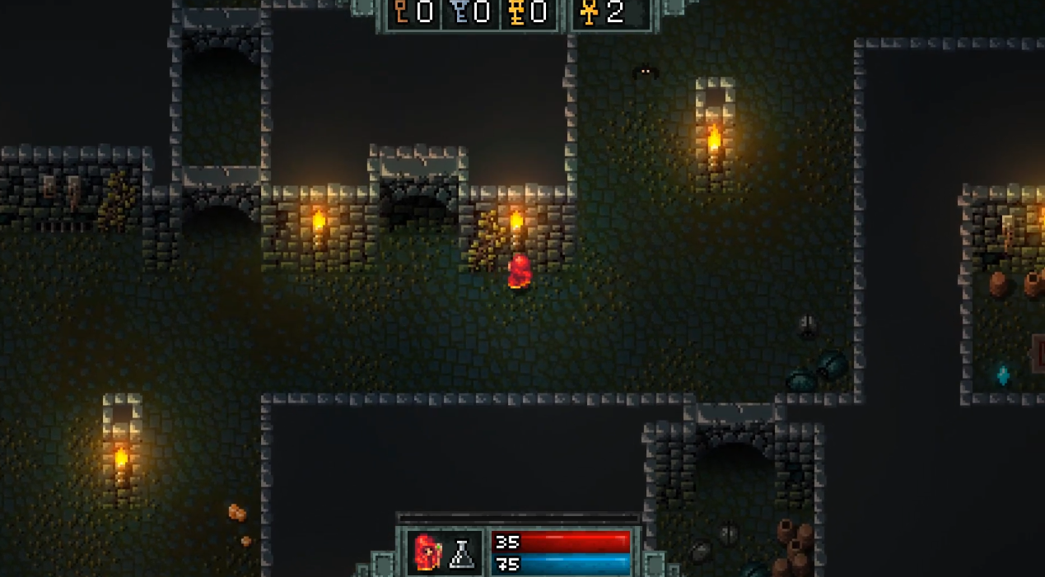
The game could look somewhat like this (photo below) but with dynamic path traced lighting system (to be continued)

